**Course Methods Test 2 Year 12**

Student name: ________________ Teacher name: ________________

**Task type: Response**

**Reading time for this test : 5 mins**

**Working time allowed for this task: 40 mins**

**Number of questions: _____6______**

**Materials required:** Upto three calculators/classpads

Standard items: Pens (blue/black preferred), pencils (including coloured), sharpener, correction fluid/tape, eraser, ruler, highlighters

Special items: Drawing instruments, templates, notes on one unfolded sheet of   
A4 paper,

**Marks available: 41 marks**

**Task weighting: 13%**

**Formula sheet provided: no but formulae listed on next page.**

**Note: All part questions worth more than 2 marks require working to obtain full marks.**

Useful formulae

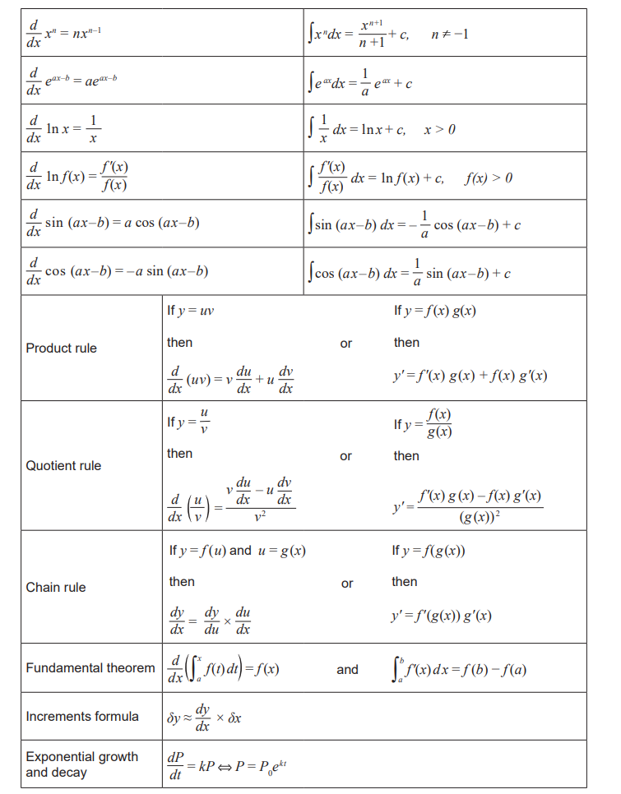Q1 (2, 3, 2 ,2 & 3 =12 marks)

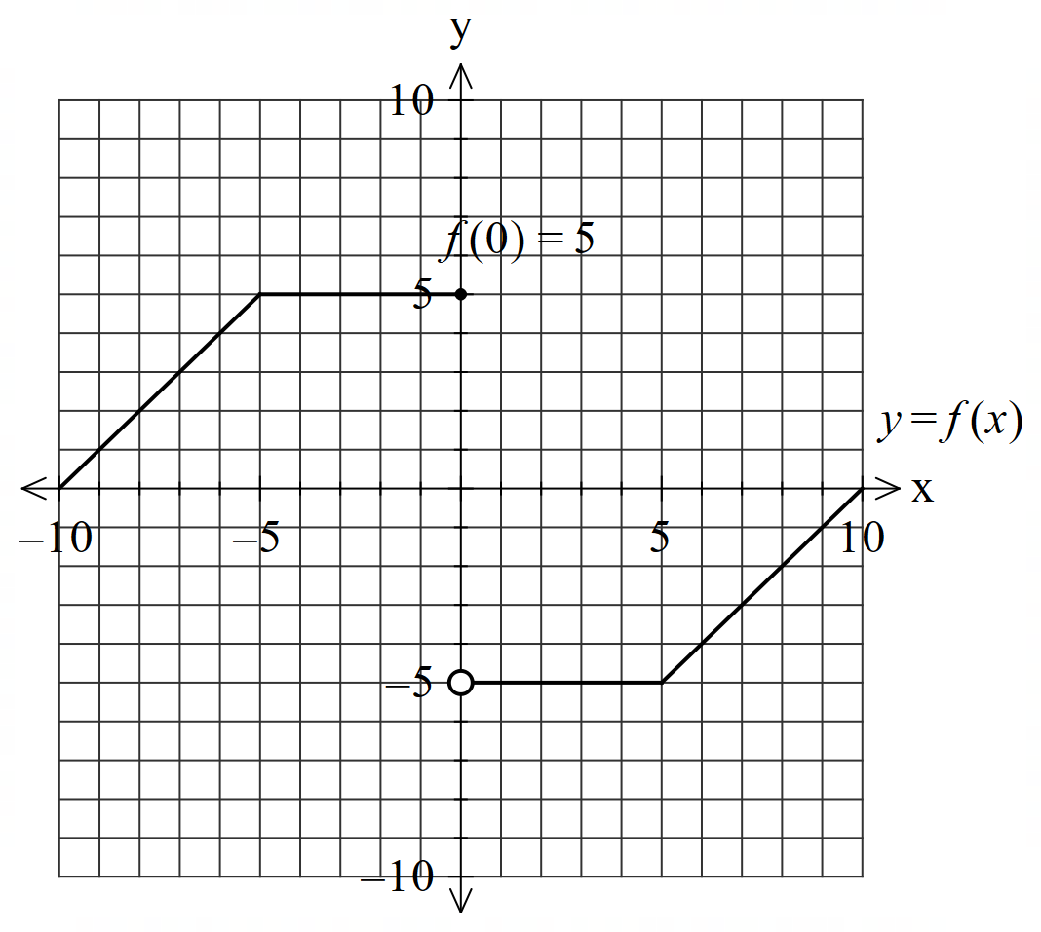Consider the function  which is graphed below.

1. .
2. .
3.  when .
4. .
5.  in terms of  for .

Q2 (4 marks)

Sketch a continuous function **showing the  coordinates and labelling** of all special features on the axes below that meet the following requirements.



Has **exactly** two stationary points.

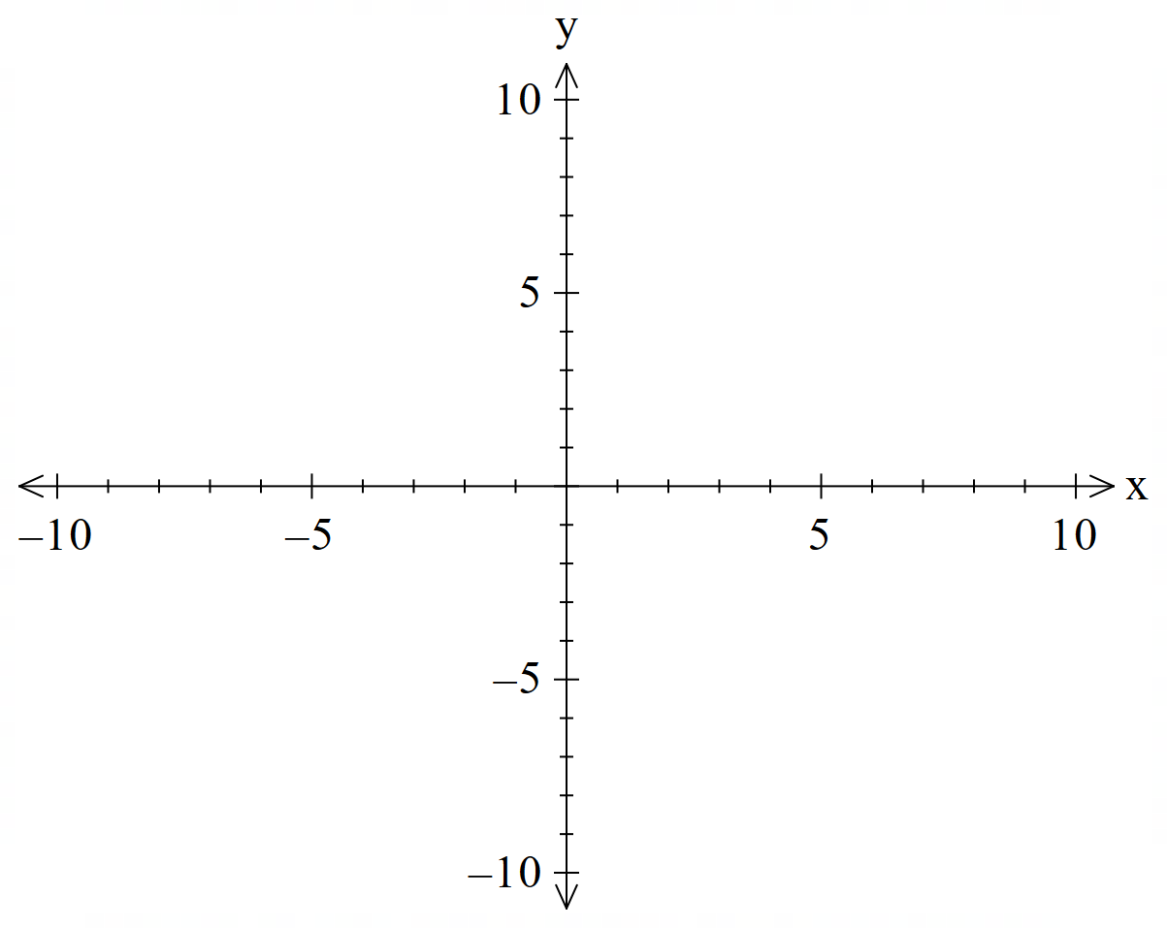

Q3 (3 marks)

Consider a balloon whose volume , litres, varies with time, seconds, such that.

If the balloon fully deflates after 12 seconds, determine the initial volume. Full reasoning must be shown for full marks.

Q4 (2, 2 & 3 = 7 marks)

An object’s displacement,  metres at  seconds, from the origin is metres.

1. Determine the velocity function at time  seconds.
2. Determine the first two times that the object changes direction.

Q4 continued-

1. Determine the distance travelled in the first 1.5 seconds.

Q5 (2 & 4 = 6 marks)

1. Determine  **without the use of a classpad**. Full reasoning must be given.
2. Hence show how to determine  **without the use of a classpad**. Full reasoning must be given **using** the result from part a.

Q6 (2, 4 & 3 = 9 marks)

Consider a glass wall with the height metres **above floor** at  metres along the floor according to

 . The glass wall sits on a stone support of height 8 metres.

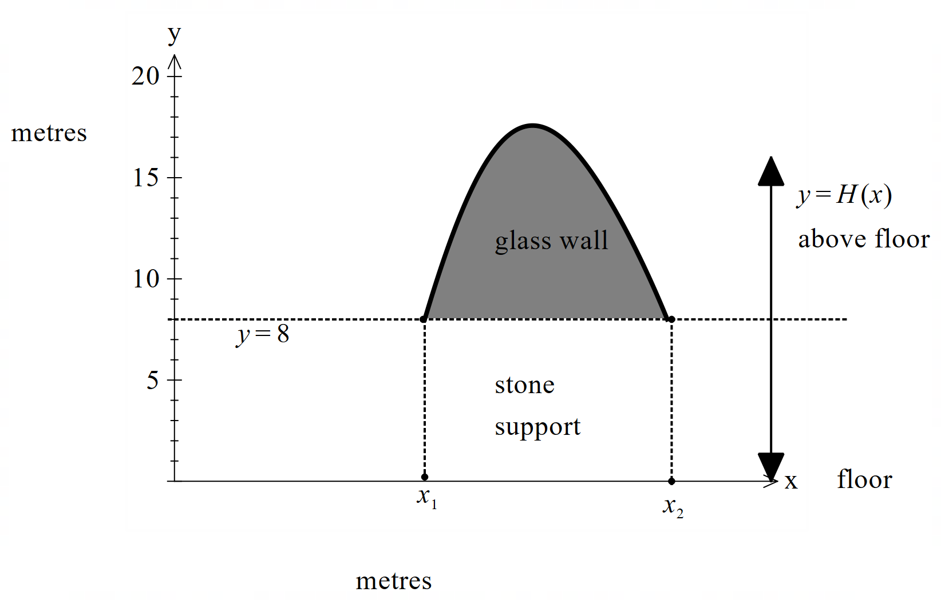

1. Determine the values  to the nearest cm.
2. Using calculus, determine the maximum height of the wall. Justify.

Q6 continued

1. If the wall is 5 cm thick determine the volume of glass with units, needed to make the wall.

End of test.